DRUG COURT RECOVERY MAINTENANCE CHECK-IN

GUIDELINES FOR ADMINISTRATION

Background and Purpose of the Inventory

This checklist was developed for use by drug courts and/or their treatment partners as a means of monitoring drug court participants during the most vulnerable period following their discharge from services in order to offer any needed support and services and to prevent relapse/re-offense. It is also to provide help in re-integrating into needed services. It is well documented that drug dependence is a chronic, relapse-prone disease. The whole movement toward a chronic care model for the treatment of addiction, often referred to as Recovery Management
is taking hold in the new healthcare environment. Drug courts should be aware of the need for extended services for participants beyond those that occur during the formal course of the individuals’ involvement in drug court. Research has shown that maintaining contact with graduates, particularly during the 90 days post discharge from drug court, can have a significant impact on the prevention of relapse and re-offense and the maintenance of recovery.

The Recovery Maintenance Check-in [RMC-i] is a tool that drug courts should feel free to use as
a key component of Recovery Oriented Systems of Care. The Check in may be altered or terms defined according to the culture and needs of each drug court. Nothing in the Check in tool is intended to be prescriptive or mandated. Drug courts are urged to experiment with the concept of recovery check- ins and to track their results.

Recovery management check-ins [periodic contacts] are an evidence-based practice. Drug courts can adopt this practice to meet the new NADCP Adult Drug Court standards. To facilitate these contacts, this Drug Court Recovery Maintenance Check-in [RMC] may be used. Drug courts should inform participants early on that check-ins will be conducted and there will be contact beyond the term of the formal drug court involvement. It may be easiest to include such notice in the drug court contract that inductees sign when they are initially admitted to drug court as well as to include it in the drug court participant’s manual.

Structure of the Checklist

The RMC-i was developed for use as a telephone contact in which interviewers call drug court graduates [including those who have not been successful for which contact information is available] at periodic intervals and administer the checklist. Recommended periodic intervals based on previous research are as follows: monthly for the first six months post discharge, bi-monthly for the next twelve months and quarterly for the next eighteen months for a total of thirty-six months.

The form provided may be used electronically and the information stored, or it may be done with paper, pencil. The RMC is designed for use by professionals and non-degreed professionals alike and is intended to reach populations where formal education may be limited.

Questions are deliberately constructed to be open-ended and to elicit conversation and whatever information the respondent chooses to disclose. The primary purpose of the questions is to identify current problems and/or areas that the participant may need additional services for.

The domains of the checklist; Housing, Family/Social Status, Health Status, Substance Use, Financial/Occupational Stability, Criminal Activity have been targeted based upon the research that indicates that problems in these areas are likely to undermine recovery and trigger relapse/re-offense in recovering populations. These domains were also identified for inclusion in the National Outcome Measures [NOMS] by the Center for Substance Abuse Treatment as essential to conducting outcome evaluation. By using the rating scales at the end of each domain in the text field provided, a drug court may incorporate the aggregated findings into its quality monitoring or program evaluation component. The rating scales are defined later in this Guide, however, drug courts may wish to use different rating scales or definitions. The ratings used in this tool when aggregated, are intended to give drug courts some idea about the most frequent areas of difficulty their participants experience in early recovery. By understanding these issues, the court may then wish to address these issues or modify their case management services to participants prior to their discharge. The ratings of the stage of change the participant is in provides a similar opportunity for drug courts. When these ratings are aggregated, it may help the drug court better plan interventions to help clients maintain their action stage of change.

The RMC-i is scripted to permit a wide range of individuals to conduct the calls. Text fields are provided to permit notes to be made of pertinent answers.

Interviewer Requirements

No special training is required to administer the RMC; however, some experience with Motivational Interviewing techniques and drug court processes is preferred. Knowledge of community resources is also helpful and if available, a community referral information directory. Drug court coordinators, treatment staff, volunteer or paid mentors and others associated with drug courts are generally used to carry out recovery checkups. Interviewers should be familiar with federal and state confidentiality regulations.

Interview Style and Approach

The motivational interviewing style will optimize the inventory results. Motivational Interviewing is intended to strengthen a person’s motivation to make needed changes The RMC utilizes the OARS, a technique employed in motivational interviewing to enhance rapport and trust, and to encourage collaboration and information sharing:

O - The “O” in Oars means open ended questions. Thus the RMC questions are intentionally designed to encourage elaboration by the drug court participant versus offering yes or
no responses. Participants are more likely to feel the interviewer genuinely cares about
them when they are intently listened to and when the other elements of motivational interviewing are used.

A - A refers to affirming. Affirming is the practice of positively verbally reinforcing the participant for thinking about or making changes or for the constructive steps they are
taking to solve problems. Statements such as “that is good thinking, good job, sounds like a good idea etc. are examples of affirming.

R - Reflecting is intentionally identifying the feelings the participant is experiencing and reflecting those feelings back. This is perhaps the finest art in listening; sometimes referred to as active listening. To be able to reflect the feelings of another person, one has to be willing to listen and empathize with the speaker in a collaborative relationship.
“It sounds like you must be feeling very frustrated…It is discouraging when…..” are examples of reflecting feelings.

S - The “S” represents the final step in listening which is to summarize what has been said or discussed in a conversation. When the interviewer is able to summarize the issues or concerns of the participant, he/she is likely to feel “heard” and understood.
Clearly, when one feels heard and understood, trust and confidence are more likely to emerge and the participant feels more inclined to ask for help that is needed. The Inventory ends with summarizing.

User Instructions:

The RMC is divided into 9 sections. Each section is labeled with a title in all caps, bold text. The sections include Client Data, Greeting, Housing, Family/Social Status, Health Status, Substance Use, Financial/Occupational Stability, Criminal Activity, and Overall Summary.

Throughout the checklist, capitalized text is used for section titles, labels and instructions to the interviewer. Capitalized text is not read aloud to the respondents.

RESPONDENT DATA SECTION: [First Section]
This section should be completed prior to calling the respondent. The Collateral line refers to the contact person identified by the respondent at the time the drug court coordinator explained the RMC process and should be a third person close to the respondent who will always know where and how to contact the drug court client. Examples are parents, spouses etc. Verify with the respondent that this information is accurate and the contact person is still the most reliable source.

GREETING SECTION:
The purpose of the Greeting section is to get the respondent comfortable with the interview process, build some initial rapport and to confirm their availability for the phone call.

The next six sections (Housing, Family/Social Status, Health Status, Substance Use, Financial/Occupational Stability, Criminal Activity) are divided into 3 sub-sections including the oral questions to be asked, MI prompts and a section summary that includes rating scales, a short yes/no question and an area to document impressions/follow-up plans and recommendations.

The question sub-sections include a series of open-ended questions that may be read to the respondent. Each question is preceded by a number followed by a line. This is provided as a check list so interviewers can check off each question as they complete it. Many of the questions have a corresponding follow-up question. The follow-up questions are labeled a,b,c, etc. For example, the first follow-up question to question number 3 would be labeled “3a” the second would be labeled “3b.” Follow-up questions also include instruction to the interviewer about when that follow-up question should or should not be asked. For example, the instruction “IF NO” indicates the interviewer will ask the follow-up question if the answer to the current question is no. These instructions are not read aloud to the respondent.

OPEN ENDED QUESTIONS

Most of the questions are open-ended, meaning there are not answer choices provided. These questions are designed to invoke more than just yes/no responses in the MI style. If you find you are getting very short, non-descriptive responses, use probes such as “what else can you tell me about that?” or “what do you mean by that?” to elicit a more complete response. Record as much of the response that answers the question as you are able. Remember you will need to return to this information after the interview when you complete the summary for each section as well as the overall summary at the end of the checklist. The more key points you can record during the interview, the more complete your summary will be and thus your recommendations.

SUBSTANCE USE SECTION

In this particular section you will note that the first question that that is asked is whether or not the respondent is still under supervision [on probation or parole]. Be sure you follow the instructions carefully here and do not ask a respondent who is under supervision any of the specific questions about their use if you are mandated to report any relapse to a probation or parole officer. In some jurisdictions, this is a requirement of any court officer.

The second sub-section is labeled “MI Prompts.” MI stands for Motivational Interviewing. Throughout the conversation you should provide affirmation to the respondent regarding the things he or she is disclosing in response to the questions. The text provided in the MI prompts is intended to be a guide to help you provide affirmation in that particular section.

The last sub-section is a summary section. This sub-section begins with “STATUS [CHECK ONE].” This sub-section should be completed after the phone call is finished. Once the checklist is finished and the respondent is no longer on the phone, the interviewer will return to each of the section summaries and fill in the data. Each section summary includes a status scale a yes/no question, an MI rating and space to document impressions, follow-up plans and recommendations. When completing the summary, first review the information collected in the question portion. Using that information record what you think the appropriate status of the respondent is. Choose only one status on the scale. Similarly, chose one MI level you think is appropriate for the respondent. The MI Level is intended to measure the respondent’s willingness to change. Then, choose yes or no to indicate whether or not the respondent communicated that they wanted assistance with this section. Finally record your thoughts, observations, and recommendations for the specific respondent for each of the sections. Record as much information as you feel is relevant in order to document any issues that may merit further attention or follow-up. Your impressions are important to record here because you may not be the person who makes the next RMC-i call. Include as much information as you think a new caller might need in order to acquaint themselves with the respondent. This is also the place to note your recommendations for future contacts or for other services from which the participant could benefit. It is not necessary to record everything the respondent says, particularly if it is off topic.

OVERALL SUMMARY SECTION

The last section in the checklist is the Overall Summary. This section provides the respondent an opportunity to share any other information they wish. Record their comments as close to word-for-word as you can. After recording their comments, summarize the positive issues, saying them back to the respondent and then help and problem areas you noted, saying these back as well. Finally, confirm the next contact with the respondent. Always end each call by affirming the respondent for their continued efforts at recovery.

Electronic Instructions

You will need to purchase Adobe Acrobat Pro to use this form electronically. Be sure and shop for this version to get the best price. The advantage to using the electronic version is that your data is stored and can be downloaded to a spread sheet for tabulation and ease of analysis of the data. It also saves time for the interviewer

- Install Acrobat Pro
- Create Adobe ID
- Open Adobe FormsCentral

- Upload form to Adobe Form Central – select File -> Import PDF Form

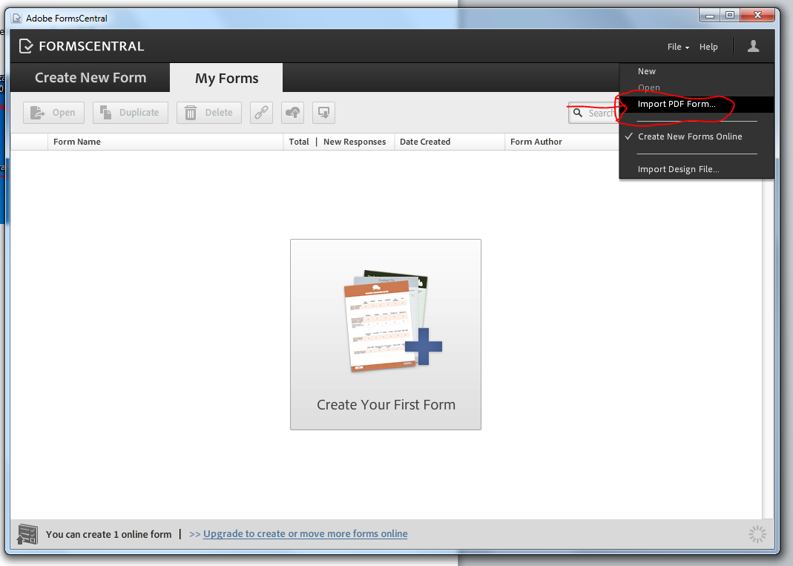

- Browse to the Recovery Form
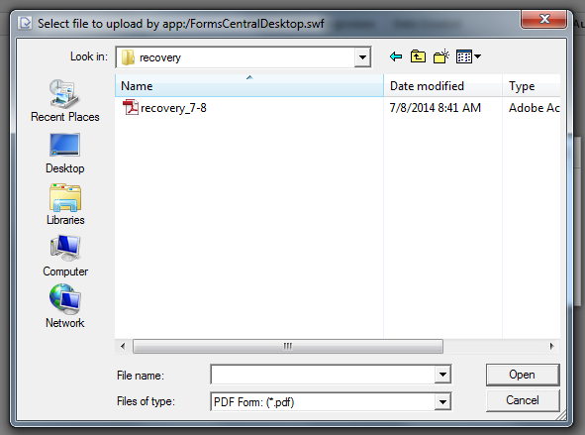

Select Import
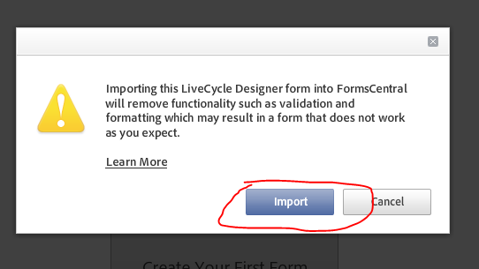

- Distribute Form
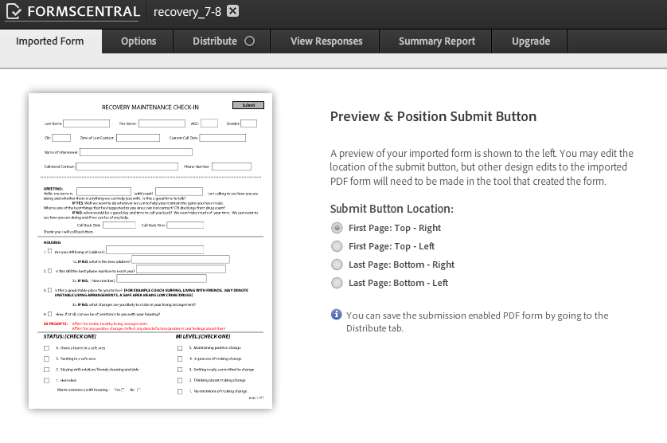

- Select the Distribute tab -> select the open button -> Download form
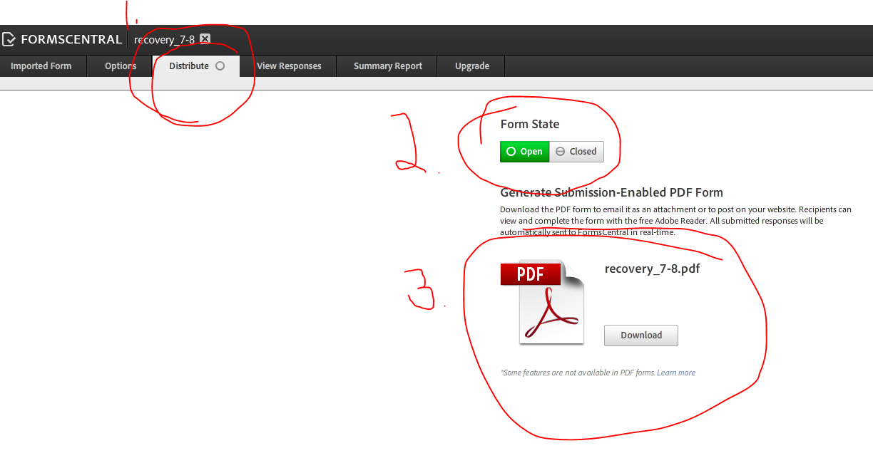

- Save the downloaded form to your PC somewhere you can access or find it easily.
- Email the form as attachment to participant filling out the form.
- Collecting results – when participant is done filling out the form and clicks the submit button the form is automatically uploaded to Forms Central
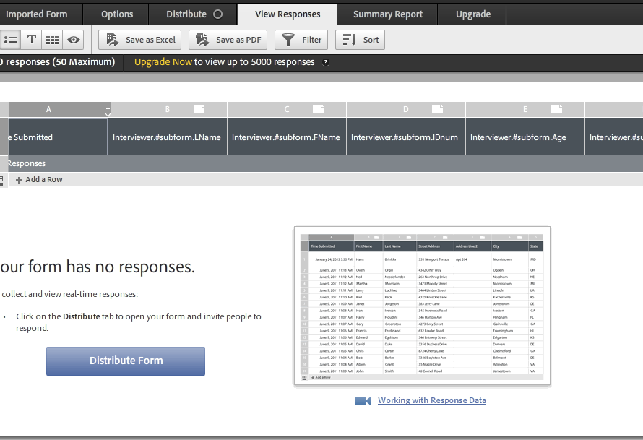
- With this version of Forms Central we are limited to 50 responses. We will have to setup a schedule to export the results as needed. To do that you will select the “Save as Excel” button
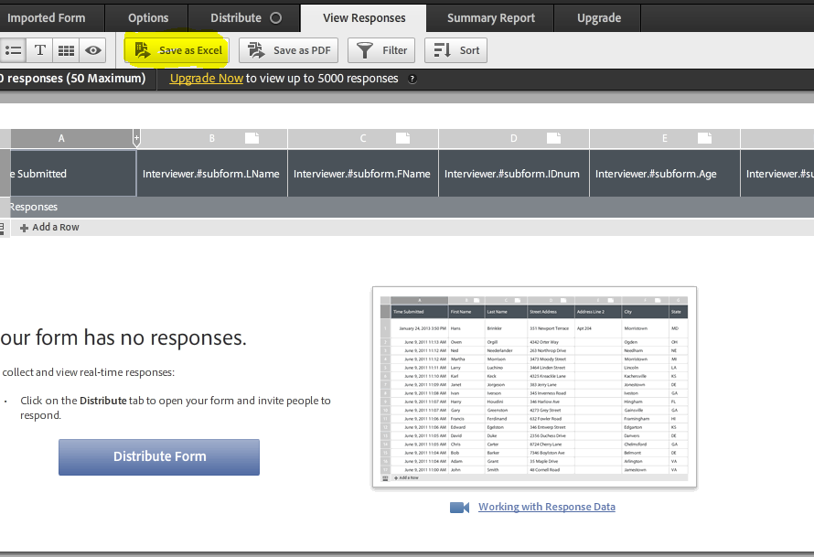
After the save to excel is finished and saved you will need to delete the responses from Form Central.
Your data will be saved in an excel spreadsheet for quality monitoring. Depending upon the version of Adobe Acrobat Pro, you may purchase a version that permits more than fifty forms to be stored before you need to download to the spreadsheet.

Adult Drug Court Best Practice Standards, Volume 1 Issue 2 Journal of Drug Courts NACP
Miller, Wm. Rollnick, Stephen; [2013] Motivational Interviewing: Helping People Change, Third Edition Guildford Press

